LONGITUDE EXPLORER PRIZE 2019 / 2020

BUSINESS PLAN WORKBOOK

Congratulations!

You have reached the finals of the Longitude Explorer Prize

We hope you have enjoyed participating in the Prize so far, and we are very excited for the final stage to see how you grow and develop your ideas.

You have done an amazing job and put forward some really impressive ideas about how you can use Artificial Intelligence to do great things,
and we have developed this workbook to help you take those ideas from the page to reality.

A note on COVID-19
We know that the current situation is a difficult time for everyone, and we hope you and your families are keeping safe and well. We will be providing resources and ideas on how you can still work as a team remotely on our website.

Contents:

1 Background information about the Prize 3
2. How to use this document 4
3. Guidance and key dates 5
3.1 Judging Criteria 5
3.2 Mentoring 6
3.3 Contact details 6
4. WORKBOOK – ACTION PLAN 7
4.1 Summary of your idea 8
4.2 Description of team: roles & responsibilities 9
4.3 The problem you are addressing 11
4.4 Market research – innovation 12
4.5 Turning your idea into reality 13
4.6 Application to the real world 15
4.7 Communication 17
4.8 Security & ethics 18
4.9 Team reflections 19
4.10 Other notes and comments 20
5 Tools and resources 21

1. Background information about the Prize
The Longitude Explorer Prize is delivered across the U.K., with teams from across the country working hard to bring their ideas to life. The Prize is open to 11-16 year olds, who work in teams of two to five to come up with amazing ideas and bring them to life.

The challenge

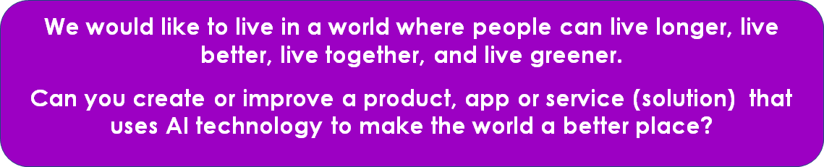

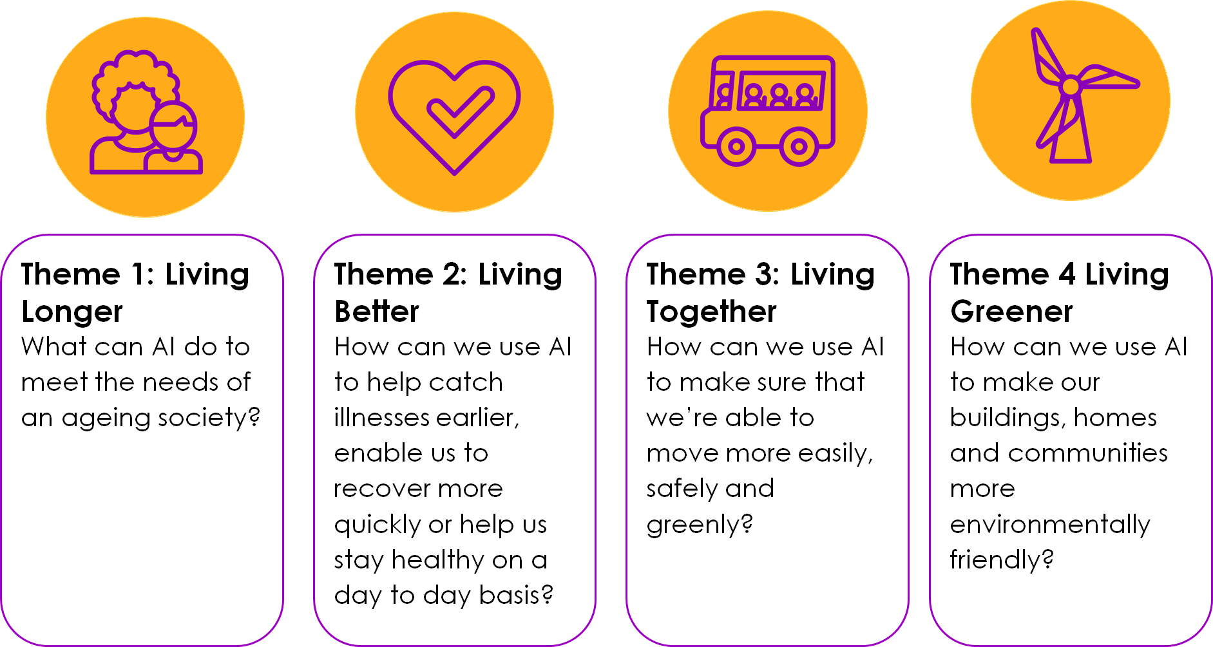

2. How to use this document

This document will help you tell the judging panel about your idea and show them the work you have done to develop it. You should work as a team on this document (remember, teamwork is a key judging criteria!). If you are at home, you might have to change the way you would normally work if you can’t meet in person. There are lots of ways you can still do this, such as:

- Working on a shared document, such as a Google Doc, so you can all work on it at the same time.
- Work on a Word document version, and each work on an individual section before sending it on to the next person in your team. When everyone has done their section, you could have a phone call to discuss your working.
- Having weekly check ins with your teammates to check your progress

We know this seems like a long document, but remember - every big task is made up of lots of smaller tasks. So, come up with a plan with your team and assign different tasks.

You have had huge success in getting to this stage and have done lots of work already to come up with your idea - this is a chance for you to build on this success!

Lots of small steps lead to big results!

3. Guidance and key dates

Completion of this workbook is a requirement for the final stage of the Prize. All workbooks will be assessed to help the judges select the winner!

Workbooks need to be submitted electronically by sending a PDF and a Word version via email to explorer@nesta.org.uk by 12pm (midday) on Monday 22nd June. You will also need to submit your pitch as a video (you will receive more guidance on this in early May).

You will need to complete all sections (4.1-4.10) of this workbook to develop your action plan for the design and development of your concepts to a prototype or final product.

The workbook will ask you key questions to guide your thinking about how you get your idea from concept to reality.

Some of the questions may appear to be asking for similar information that you have submitted before, however, this is an opportunity to refresh the idea and provide more detail that will help the judges make the decision about who will win the Longitude Explorer Prize.

Remember, we have lots of resources on our website to help you. We will also host 4 webinars on the 4th, 5th, 6th and 7th May, which will be available live and as video recordings to watch another time. We signpost in this document which webinars will be most relevant for each section.

Talk to your mentor to see if your idea might benefit from any updates/modifications.

3.1 Judging Criteria

Innovative use of AI  New ideas or adaptations and new interpretations of a solution: you should be able to articulate the problem and how your solution fits the theme and use of AI | Impact on your theme  Articulation of the problem and how the idea is addressing the issue: | Enterprising  A clear planning process, research and experimentation to progress the solution from idea to reality; consideration for what resources teams will need  application to the real world, how it will be made, who will use it, how much it will cost?
Teamwork  How will the team work together, how will they recognise their contributions and the strengths they can all bring to the team | Communication  How will the team market and promote their idea? | Security & Ethics  Consideration for the ethics and security issues of using AI and an idea of the type of impact the solution can have

3.2 Mentoring

Your team will be matched with a mentor, to support the development and prototyping of your idea.They will be able to discuss development with you over the course of your journey.

We will be setting up a way for you to meet and interact with your mentors online. This will be organised with your Team Champion, please let them know if you have any further questions.

3.3 Contact details
If you have any queries during the course of this stage then please email explorer@nesta.org.uk.

We hope you enjoy working through your plans!

4. WORKBOOK

LOGO

(Insert your project logo here - and then delete this text!)

Project Name___________________________________

Team Name____________________________________

School / Organisation Name:_____________________

Deadline for submission: 12pm (midday) 22nd June 2020
Submit to explorer@nesta.org.uk

4.1 Summary of your idea

Please provide a summary of your idea, being quite specific about what it is and what it aims to do.

Name of your idea:

Summary of your idea (200 word limit)
Describe the project as if you’re explaining it to someone new. What's your 30-second pitch? Provide a summary of your idea, being quite specific about what it is and what it aims to do.

Please tick the theme which relates to your idea the most:

Theme:
- Live Longer (helping the older generation to stay independent & active)
- Live Better (helping people live healthier)
- Live Together (through better transportation and tech)
- Live Greener (helping tackle pollution and energy saving)

4.2 Description of team: roles & responsibilities
In this section, please describe your team. Select the roles required in the delivery of the product, app or service - e.g. engineer, designer, press officer, marketing manager, and assign a role to the person most interested or suited to it.

Write the team member's name and the role and briefly describe their responsibilities and what work they've done to support the development of the idea.

Remember - a great way to complete this workbook is to split it into manageable tasks and for each team member to take responsibility for different tasks.

Team member name
The title of the role:
Description of responsibilities and tasks undertaken to develop the idea:

Team member name
The title of the role:
Description of responsibilities and tasks undertaken to develop the idea:

Team member name
The title of the role:
Description of responsibilities and tasks undertaken to develop the idea:

Team member name
The title of the role:
Description of responsibilities and tasks undertaken to develop the idea:

Team member name
The title of the role:
Description of responsibilities and tasks undertaken to develop the idea:

Please use the space below to tell us more about how the team has worked together.

Think about: How did you define your roles and shared responsibilities? How did you communicate with each other? What did you learn? What worked well and what would you have changed if you were to work on your project again?

We know that having to work together online rather than in person might have been challenging. How have you overcome these challenges?

Word limit (200)

Judging criteria that this section relates to:
Teamwork
How will the team work together, how will they recognise their contributions and the strengths they can all bring to the team?

4.3 The problem you are addressing
What problem or issue is your idea addressing and how will your idea address or solve the issues/problems?

Think about: What problem are you trying to tackle with your idea and why it is important? How is your idea solving or helping to solve the issue? How does the problem you’re solving fit within the theme you’ve chosen?

Word limit: 200

Judging criteria that this section relates to:
Impact on your theme
Articulation of the problem and how the idea is addressing the issue.

4.4 Market research – innovation
Webinars one and two about Concept Development and Marketing Strategy Development can help you with this section

- In this section, please describe your idea in as much detail as possible: outline what type of solution it is and if it’s a new idea or an adaptation of an existing solution.

Think about: What is your concept - an app, product or service? How does it work? Are there any similar products available? If there are similar products, how does your idea differ from others? Have you done a Google search to see what other products are out there?

Word limit: 200

- Please outline how your idea uses Artificial Intelligence.

Think about: How does your product use Artificial Intelligence? What data do you need for your idea to work? Where will you access this data?

Word limit: 200

Judging criteria that this section relates to:
Innovative use of AI
New ideas or adaptations and new interpretations of a solution: You should be able to articulate the problem and how your solution fits the theme and use of AI.

4.5 Turning your idea into reality
All the webinars can help you with this section.

a) Tell us about your planning process to turn your idea into a reality. What are the most important actions you would take?

Think about: What is the process of developing a new product? For example, think about the strategy, organisation, research, marketing plan creation, evaluation and costs. What are the key steps you would take?

Word limit: 200

b) How much will it cost to create your idea and turn it into the final product? When developing a product, it is important to think about associated costs. (It’s ok that these will be estimates!) What has your approach been to understanding these costs?

Think about: How will your product be made? What materials do you need to make it? How much will it cost to make? How much will your target audience pay to buy this product?

Word limit: 200

c) What will you need in terms of skills, industry or expert partners, software and hardware to support your actions to turn your idea to reality.

Think about: How can you use support from others to make your idea real? Are there any other partners you would involve to make your idea happen? What questions would you ask them?

Word limit: 200

d) As part of the Longitude Explorer Prize, you have been asked to create a prototype, working model or technical diagram. These will be presented as part of your video pitches to the judging panel (you will receive more information about this in May 2020).

A working prototype = a near finished physical product which is technically sound

A working model = a physical construct that represents what a prototype would look like but isn’t necessarily made to the same scale, with the same materials or have working technology (e.g this can be made with materials found in the home)

A technical diagram = a drawing of what your prototype looks like, with annotations and explanations of how it works

Please add a photo of your prototype, model or diagram in the space below:

Please outline what you have created, why you have chosen your approach and how you have created this:

Word limit: 200

Judging criteria that this section relates to:
Enterprising
A clear planning process, research and experimentation to progress the solution from idea to reality; consideration for what resources teams will need

Application to the real world, how it will be made, who will use it, how much it will cost?

4.6 Application to the real world
Webinars one (Concept Development), two (Marketing Strategy Development) and four (Product Development) can help you with this section

a) Who is your target audience? Tell us about your target audience. Describe the type of person who would use/buy your product.

Think about: Who is likely to use your product and why? What are they like? How old are they? Where do they live? What do they do? How would they use it? Why would they use it?

Word limit: 200

b) How will you design your product or service?
This section looks at the design of the product, app or service. You will need to think about what it will look like and how it will be designed to make sure people will want to use your solution.

Think about: Think how your product will be used, by whom and when, and decide if it will affect the design of your product. What features and functions will it need to work well for the target audience?

Word limit: 200

c) This section looks at how you will know whether your idea has the potential to be successful. You will need to think about how it can be tested once you have developed a prototype and how you will know if it is working the way that you expected it to.

Think about: Who is going to use it and how it will be used? This will help you think about how it can be tested. What questions would you ask people who are testing it? What would you do with their feedback? Why is this important?
Word limit: 200

Judging criteria that this section relates to:
Enterprising
A clear planning process, research and experimentation to progress the solution from idea to reality; consideration for what resources teams will need

Application to the real world, how it will be made, who will use it, how much it will cost?

4.7 Communication
Webinars one and two can help you in this section.

a) In this section, you need to think about how you are going to spread the word and get people interested in your product, app or service.

Think about: What are the communication tools for advertising a new product? Which communication tool will work best to reach your target audience? What message would you like to pass on to attract potential buyers?

Word limit: 200

b) What would be your perfect material for promotion? Is it a logo, TV advert, poster, social media campaign or a press article? Show us an example of the material appropriate to your target audience.

Think about: Is the product newsworthy? Where should you send your press release? What would a newspaper headline say? What graphics/actors would you include in your advert? What messages would encourage the target audience to try your product?

Try creating a poster or short press release as an example of the marketing material. Use words and pictures…

Word limit: 200

Judging criteria that this section relates to:
Communication
How will the team market and promote their idea?

4.8 Security & ethics

a) What are the potential security and ethical risks of your idea? (A useful resource is our AI ethics worksheet)

Think about: Is my product safe, could others use my product or service to do harm to others? How will I get my data? Do I have people’s permission to use their data?

Word limit: 200

b) What will you do to prevent these risks from happening?

Think about: What can you do to protect the people using your product? How can you explain the risks to users so they understand them? How easy will it be for users to tell you about their concerns? Are you making sure you are telling your users exactly what data of theirs you are using and what you will do with it?

Word limit: 200

Judging criteria that this section relates to:
Security & ethics
Consideration for the ethics and security issues of using AI and an idea of the type of impact the solution can have

4.9 Team reflections
a) Please add your own thoughts and reflections (300-400 words per team member) on what you enjoyed most and least about the project and on what it’s like working in a team.

Team member name:
Comments

Team member name:
Comments

Team member name:
Comments

Team member name:
Comments

Team member name:
Comments

4.10 Other notes and comments
Please add any comments or reflections here on the project that enhance or support your entry.

Think about: if money and time had been no object - what more would you have done to complete the project? Would you have done anything differently?

Thank you for completing the Business Plan Workbook. Don’t forget to submit it by sending a PDF and Word Document to explorer@nesta.org.uk by 12pm (midday) on Monday 22nd June.

5. Tools and resources
Resources and information points to support your activity.

5.1 Your mentors
- If you need help, answers or guidance try getting in touch with your mentors! They should be able to help you with most elements of a product development.

5.2 General Information
- Longitude Explorer Prize website (to be continuously updated): https://longitudeexplorer.challenges.org/im-a-longitude-explorer-finalist/

5.3 Artificial Intelligence
- Longitude Explorer resources: https://longitudeexplorer.challenges.org/artificial-intelligence/

5.4 Software & datasets resources
- Need some help finding the right dataset or software for your idea? Check out these:: https://longitudeexplorer.challenges.org/wp-content/uploads/sites/62/2020/04/LEP-Datasets-software-reccomendations-FINAL-1.pdf

5.5 Additional resources for team members
- Find resources for each stage of your journey as an innovator: https://longitudeexplorer.challenges.org/im-a-young-person/

5.6 Additional resources for Team Champions
- Activities and recommended courses for anyone supporting young people: https://longitudeexplorer.challenges.org/im-an-adult/

5.7 Remote working advice & tools
- Here is some of our favourite advice and tools: https://longitudeexplorer.challenges.org/wp-content/uploads/sites/62/2020/04/LEP-remote-working-advice-tools-FINAL.pdf

